Jira Lab Assignment 6

Harsh Rakeshkumar Bhatt

Project Management, Conestoga College

MGMT8750: Agile Project Management

Professor Shams Salim

July 11, 2023

Screenshot 1

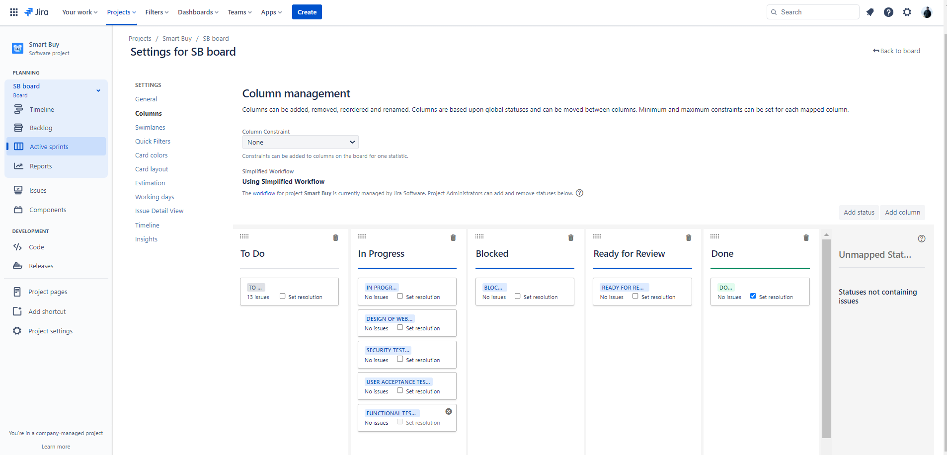

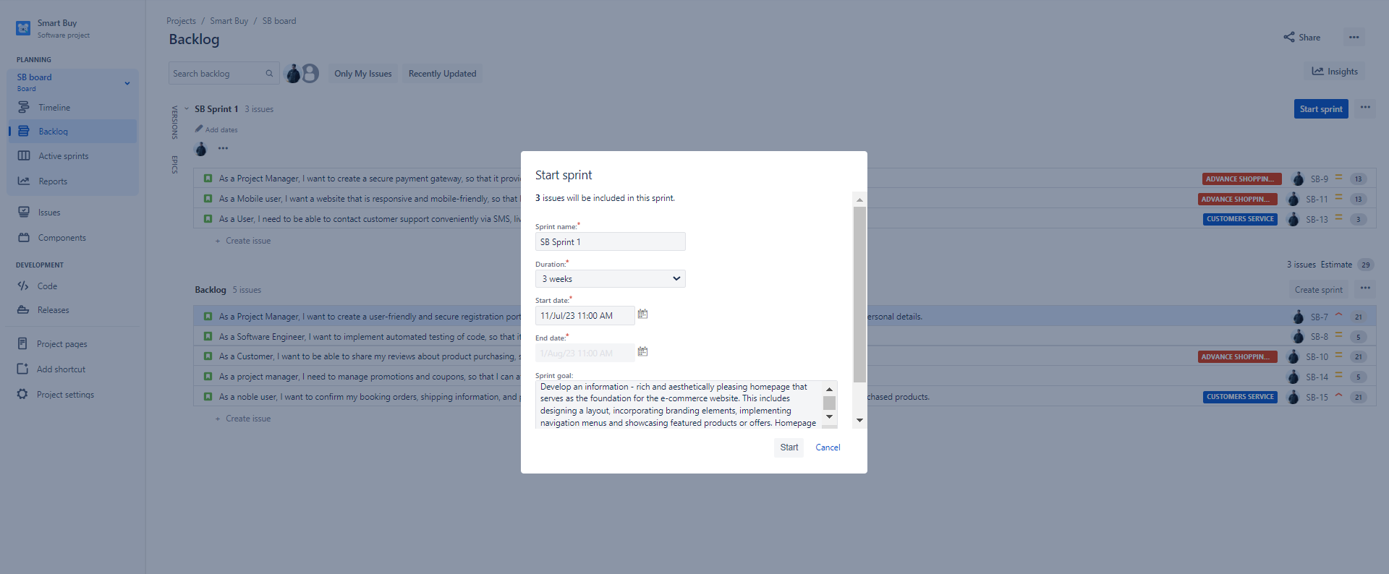
Screenshot 2
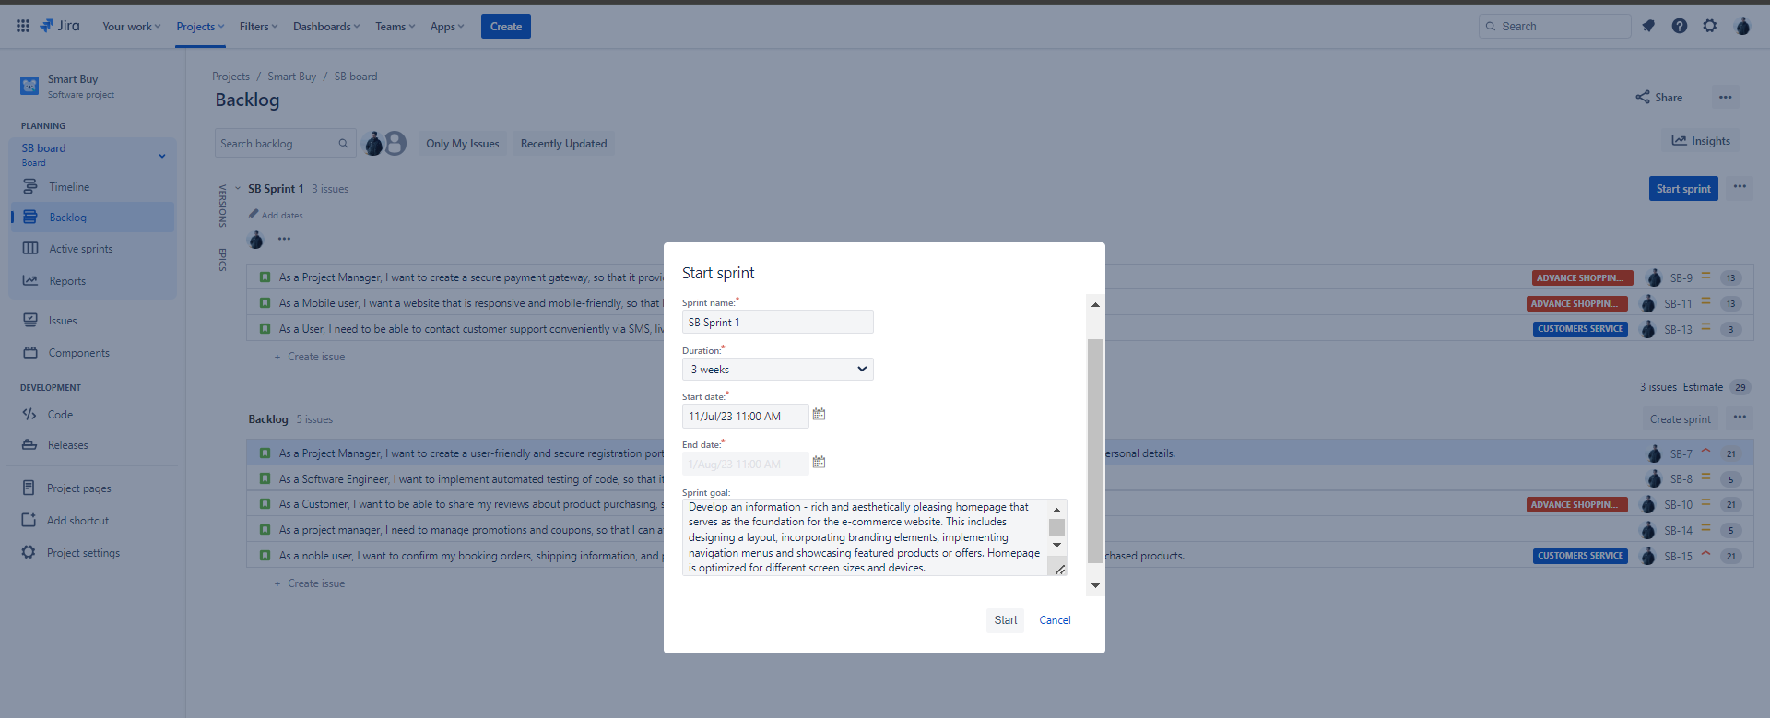

Screenshot 3

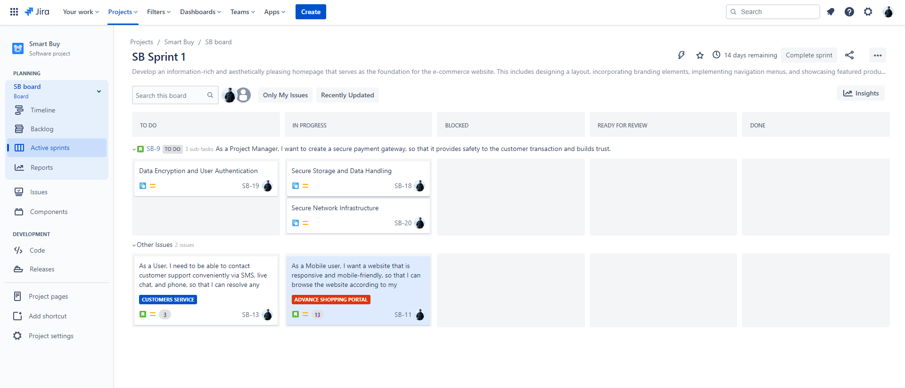

Screenshot 4

